Driving Directions to Simon Hall and Seigle Hall
Simon Hall and Seigle Hall are located on Washington University's Danforth Campus next to the Danforth University Center (DUC).

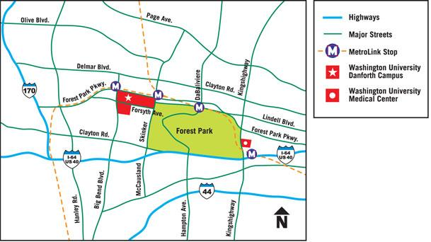
From I-70 (or Lambert International Airport)
- Go south on I-170 to the Forest Park Parkway exit.
- Go east on Forest Park Parkway through Clayton, to Big Bend Boulevard.
- Turn right (south) onto Big Bend Boulevard and continue to first stop light.
- Turn left (east) onto Forsyth.
- The Washington University campus will be on your left.
- Turn left at the second stop light, Wallace Drive.
- Wallace Drive ends at the DUC parking garage. Simon Hall is the building west of the garage.
From I-64/40, heading west
- Go west on I-64/40 to the Clayton Road exit.
- Turn right onto Skinker/McCausland.
- Turn left (west) on Forsyth Boulevard.
- Turn right at the first stop light, Wallace Drive.
- Wallace Drive ends at the DUC parking garage. Simon Hall is the building west of the garage
Campus Map
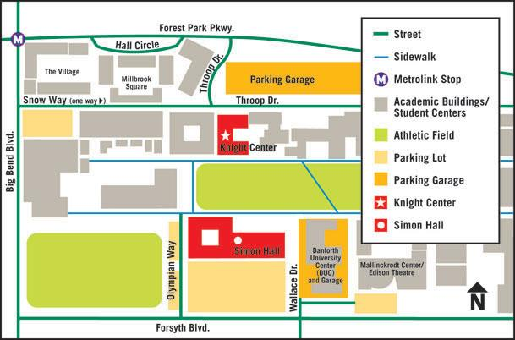
Seigle Hall

NOTE: Check-in at Simon Hall outside May Auditorium at 8:00am
- Simon Hall is located on Washington University's Danforth Campus next to the DUC.
- Parking in any Yellow parking space (except for the DUC garage) is free on Saturdays.

Missouri Regional Science Bowl
Saturday, February 22nd, 2020
Washington University

Agenda
Time | Activity | Location
8:00 am | Teams Check-in and report to May Auditorium | Simon Hall Outside May Auditorium
8:25am | Kickoff and Keynote Speaker | Simon Hall’s May Auditorium
8:50am | Teams Report to Competition Rooms | Seigle Hall – See Round Robin Schedule in Program for your team’s location throughout the morning
NOTE: All competition start times are approximate
9:00am | Round Robin 1 | Each round:  -8 min. of competition;  -2 min. break;  -8 min. of competition
9:30am | Round Robin 2
10:00am | Round Robin 3
10:30am | Round Robin 4
11:00am | Round Robin 5
11:30am | Lunch and Tie Breaker Rounds if needed | Simon Hall, May Auditorium
12:30pm | Teams Receive RR Results | Simon Hall, May Auditorium
12:35pm | Coaches and Team Captains from Top Two Teams/Division report to Command Center for Double Elimination Room Assignments | Seigle Hall Room 109
12:50pm | Teams Report to Competition Rooms | Seigle Hall – Coaches and Captains will have afternoon schedule
Teams Still Competing: Teams No Longer Competing as of 2pm:
1:00pm | DE Round 1 | Each round:  -8 min. of competition;  -2 min. break;  -8 min. of competition | 2pm: Cyber Challenge in Simon 113
1:30pm | DE Round 2
2:00pm | DE Round 3
2:30pm | DE Round 4
3:00pm | DE Round 5

3:30pm | DE Final Round(s) Begins | Simon Hall’s May Auditorium
4:00pm | DE 2nd Final Round if needed; Otherwise Awards Begin | Simon Hall’s May Auditorium
4:30pm | Awards Begin if needed | Simon Hall’s May Auditorium

